KOLLI VASANTHI

854891

Q-1:

select department_name,count(employee_id)

from departments,employees

where departments.department_id=employees.department_id

group by department_name

having count(employee_id)>=20;

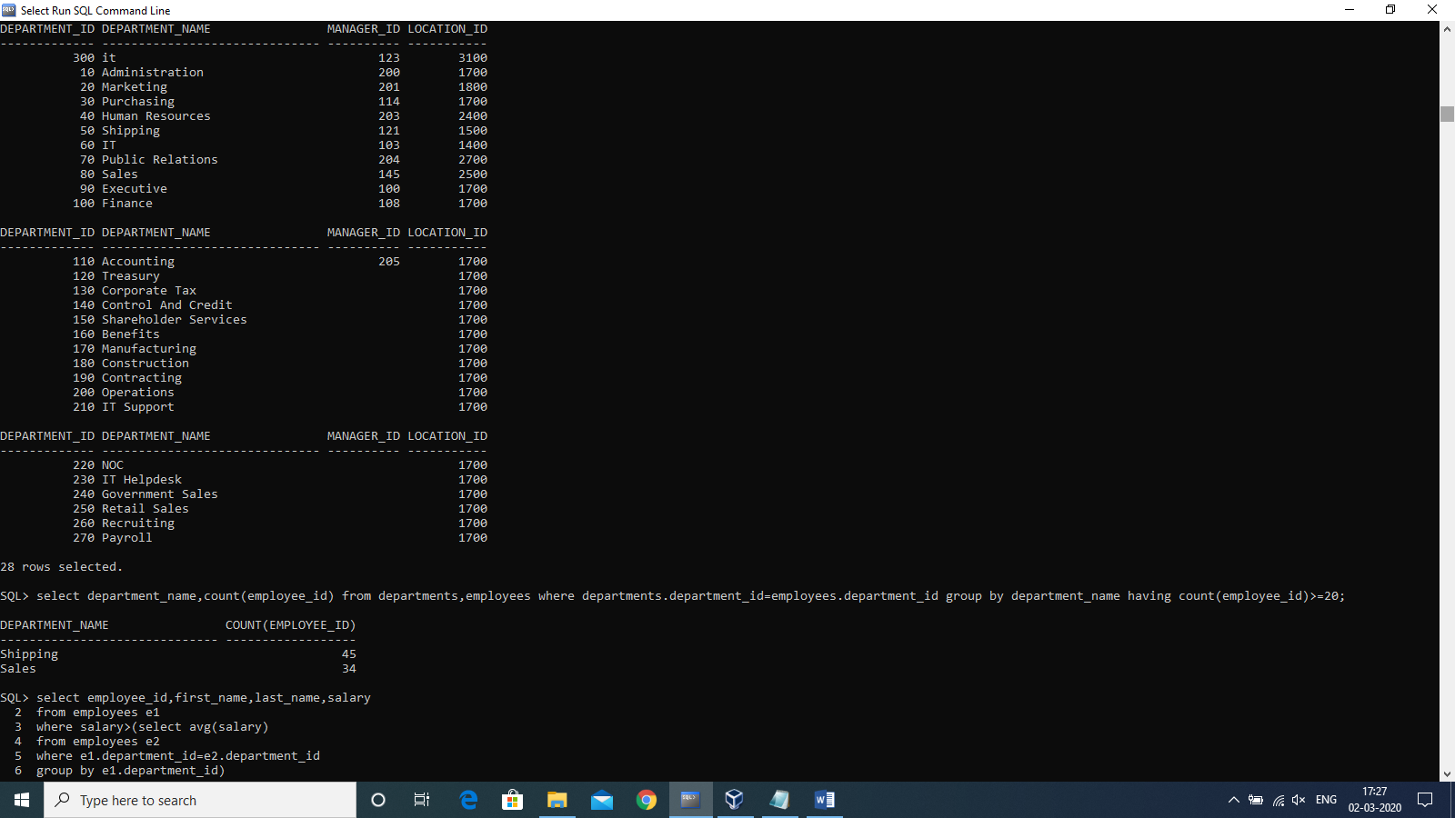

Q-2:

select employee_id,first_name,last_name,salary

from employees e1

where salary>(select avg(salary)

from employees e2

where e1.department_id=e2.department_id

group by e1.department_id ;



Q-3:

select employee_id,first_name,last_name,

first_name||' '||last_name as fullname,salary,

salary*0.1 as newsalary,(salary-salary*0.1) as difference

from employees;



Q-4:

select e1.employee_id,e1.first_name,e1.last_name,e2.first_name as manager_name

from employees e1 left outer join employees e2

on e1.manager_id=e2.employee_id

order by employee_id;



Q-5:

select employee_id,first_name,last_name,salary from employees

where rownum<=3

order by salary desc;

